**[SC472 Econometrics Data analysis Using R](https://classroom.google.com/u/2/c/NTg3NDc0OTU3MDUy" \t "_self)** **Date** – April 8, 2023

**Assignment - 1**

**Name** – Divya Kirtikumar Patel

**Student ID** - **202001420**

**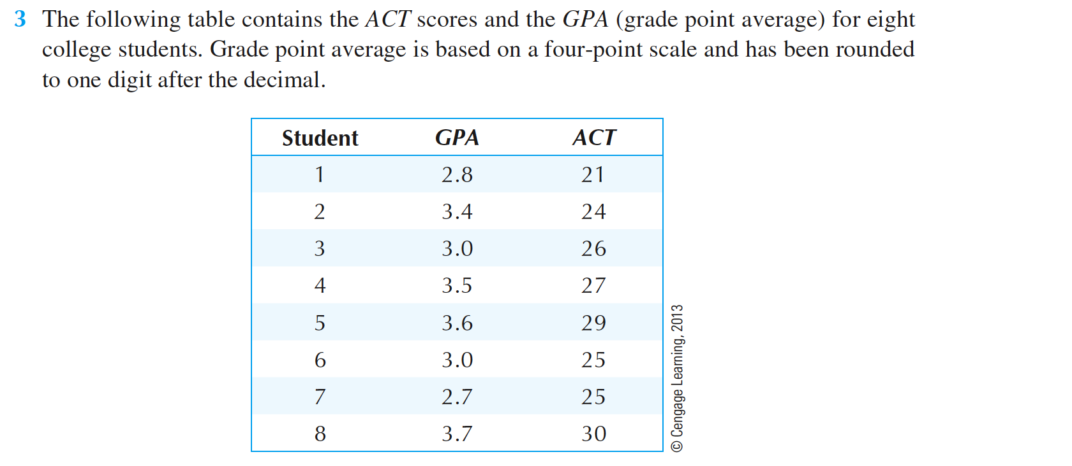**

**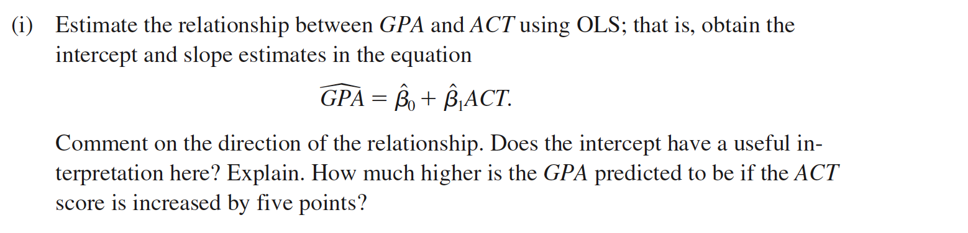**

**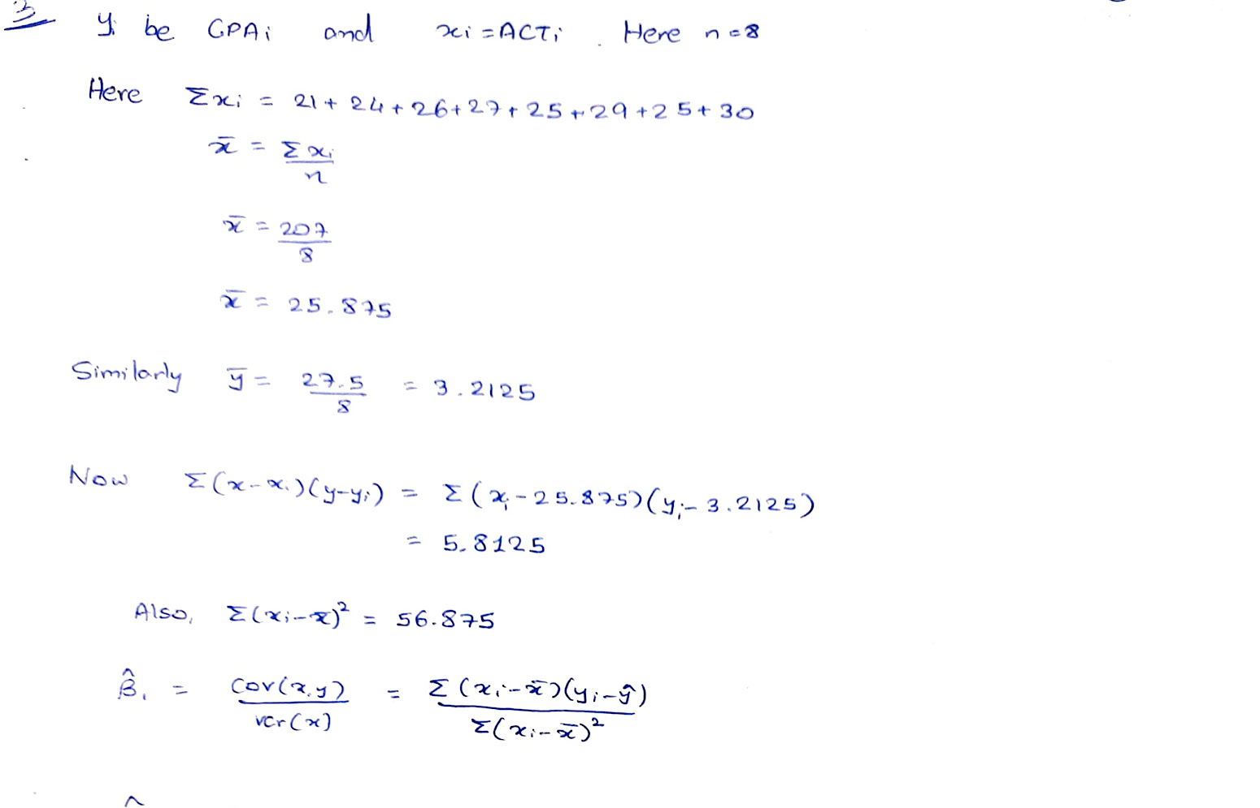**

**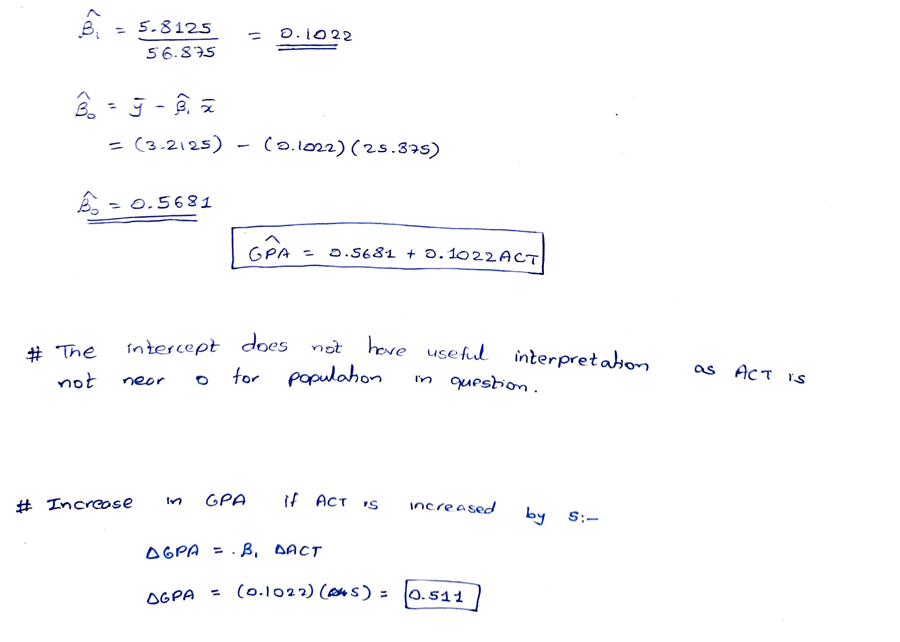**

****

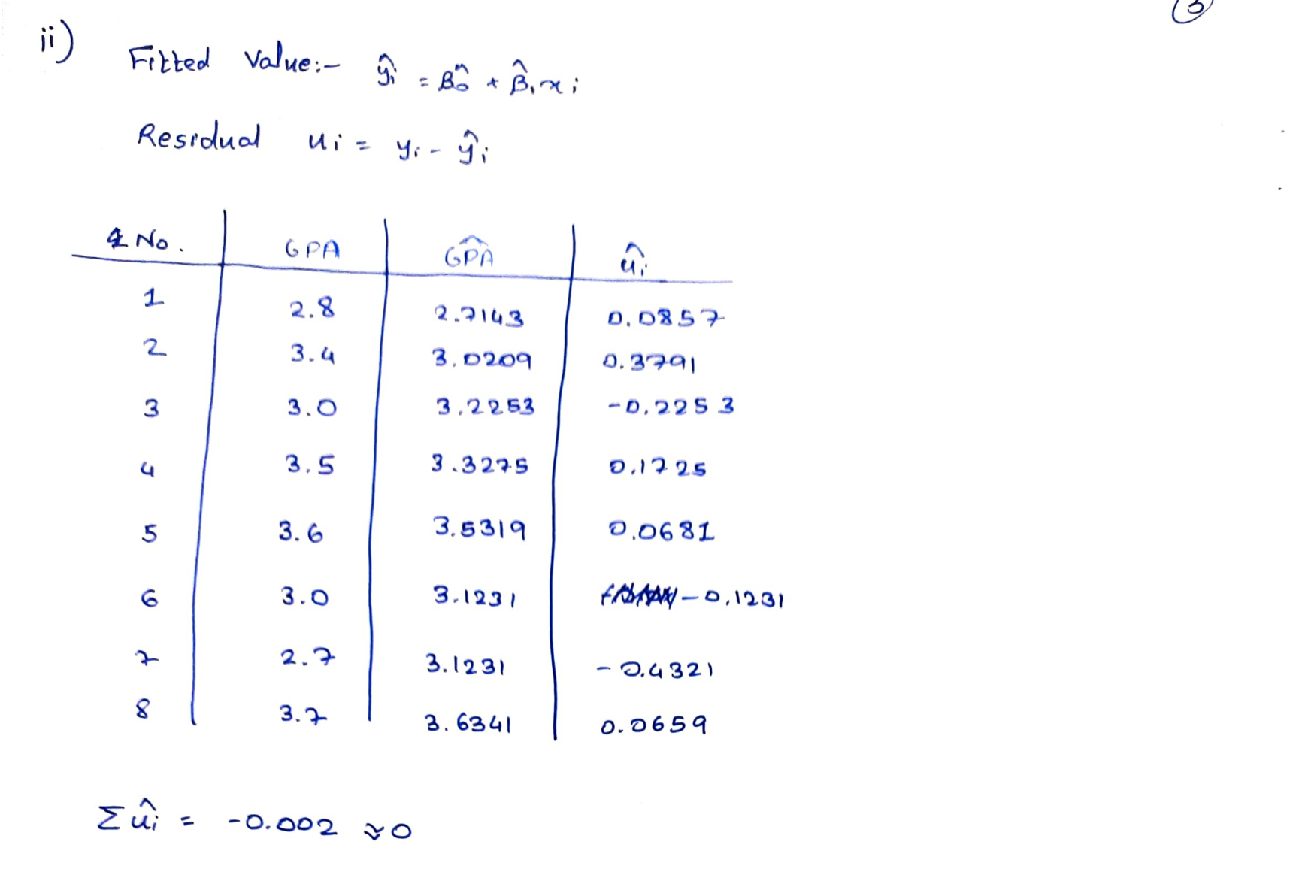

****

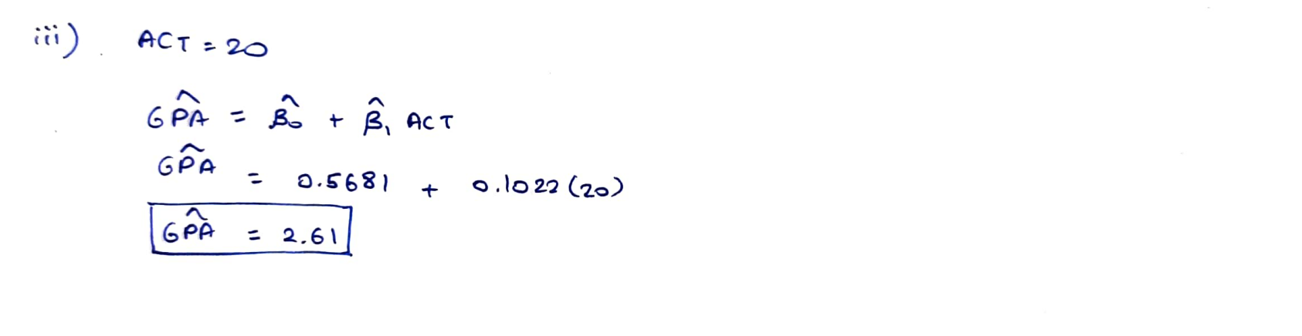



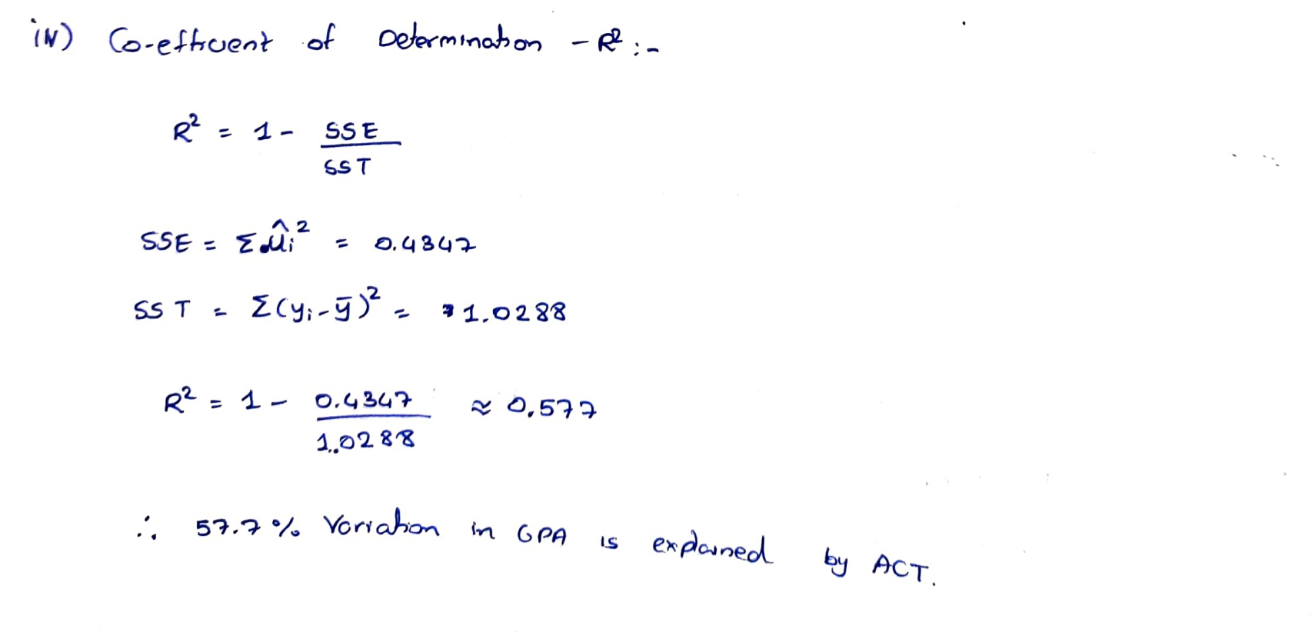

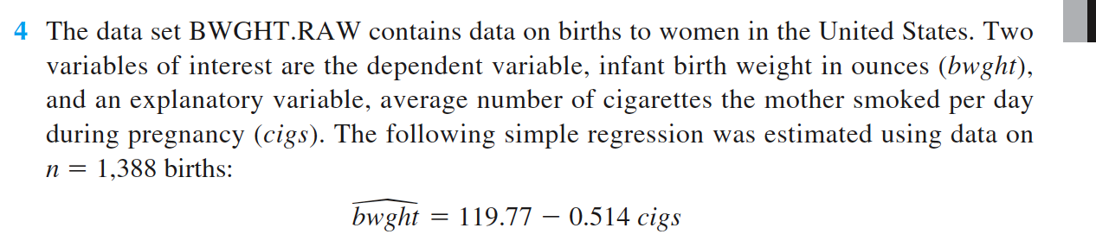 

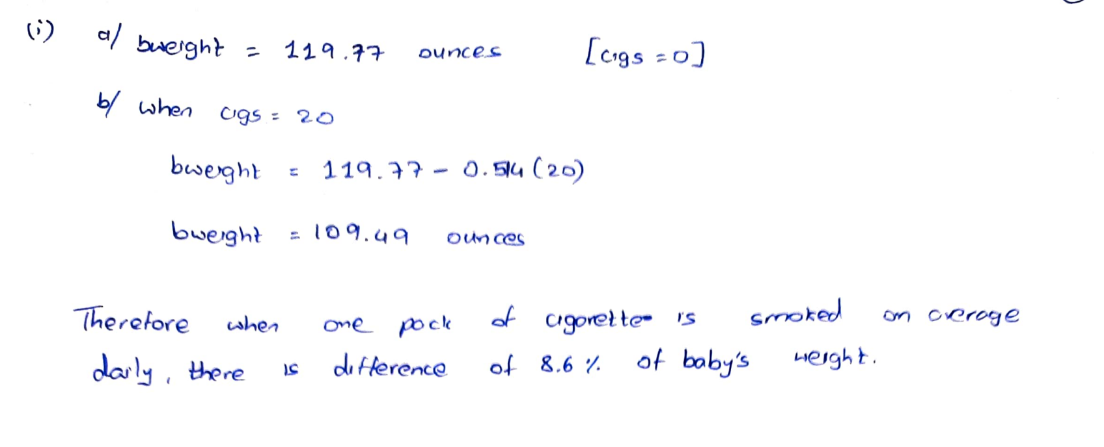



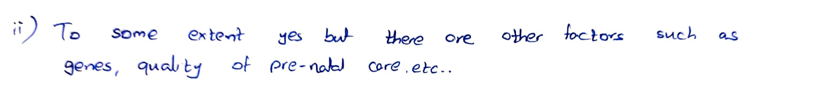



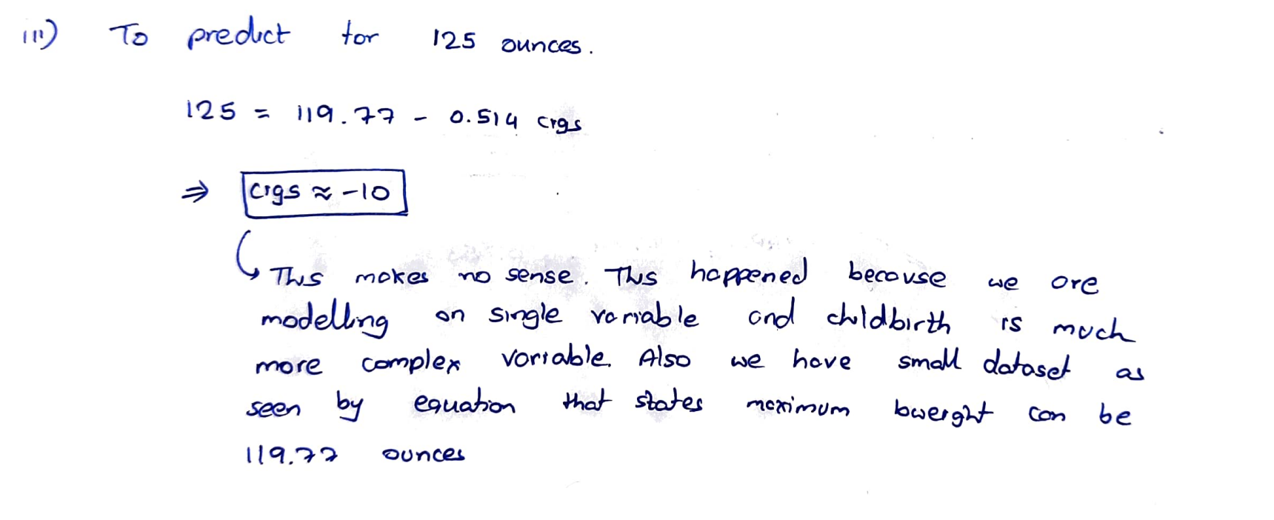



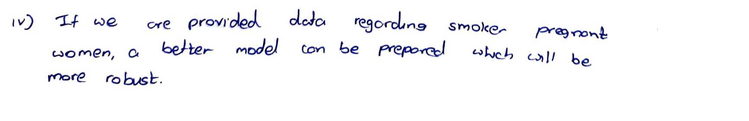

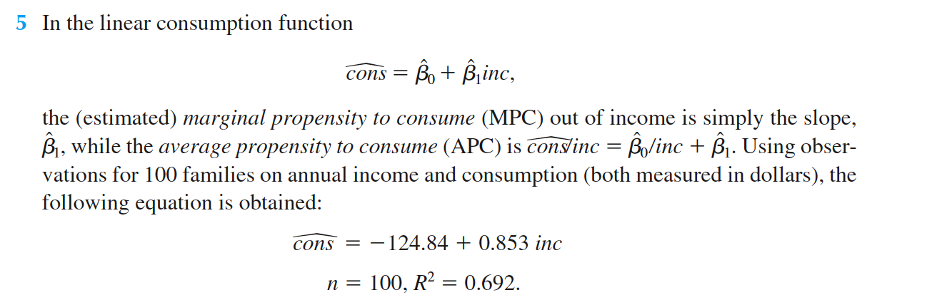 

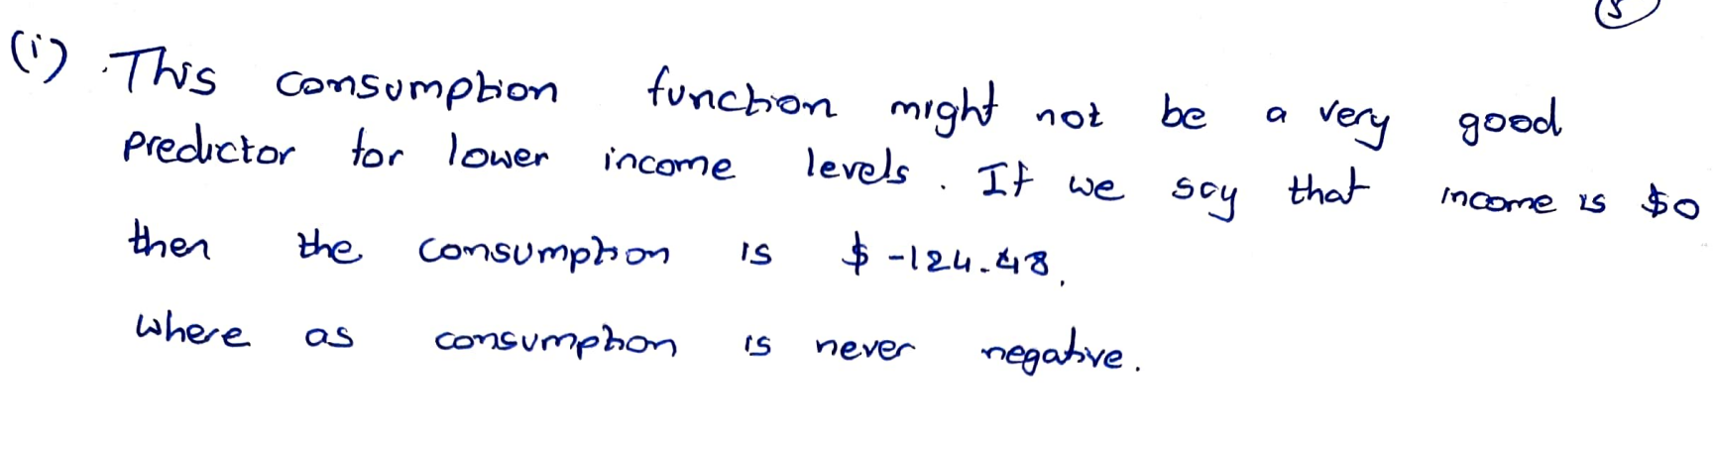



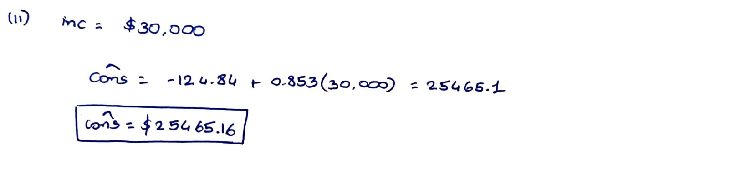



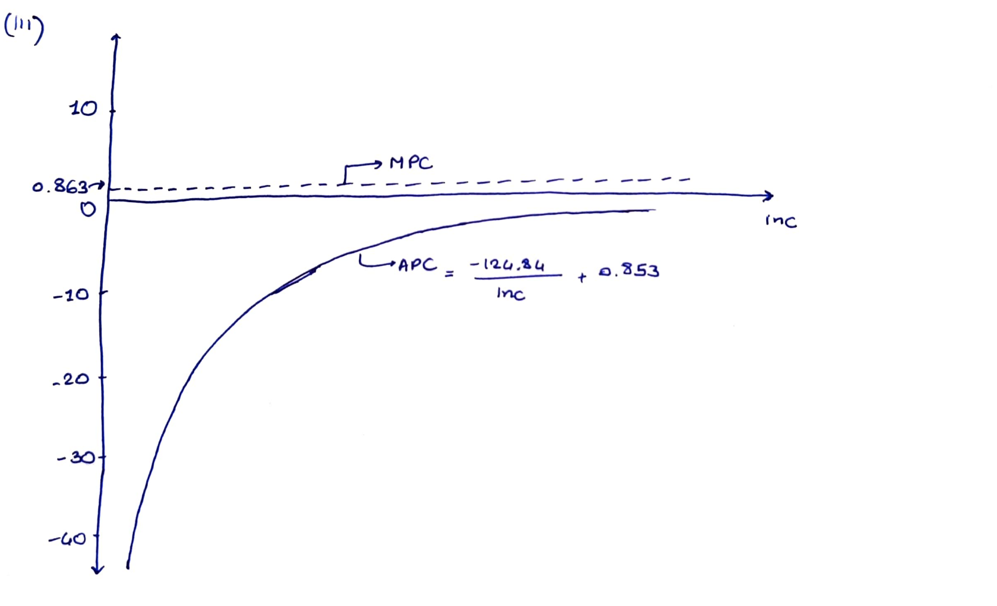

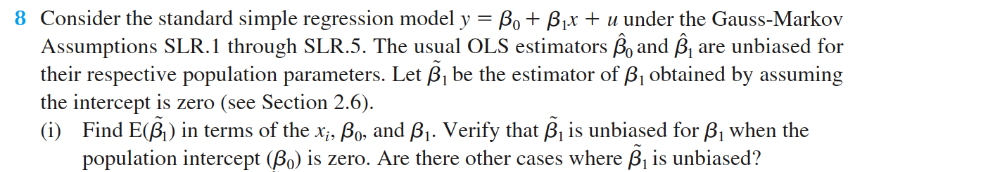

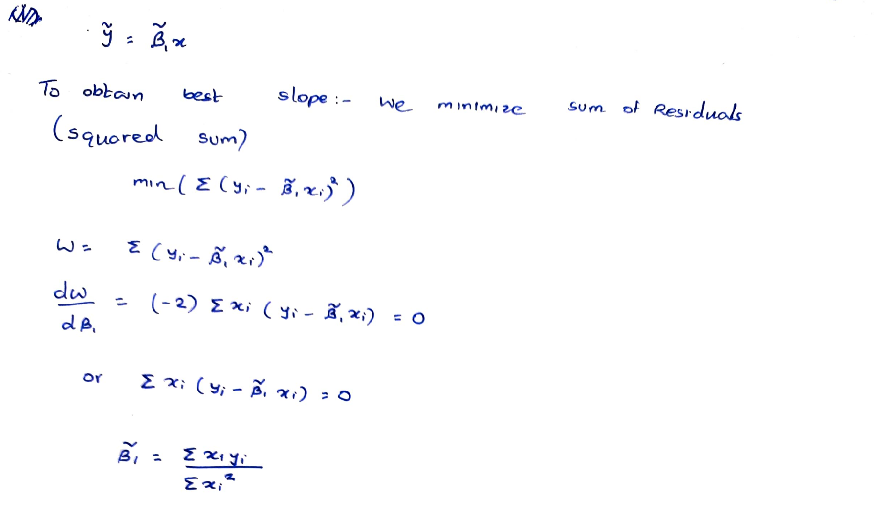

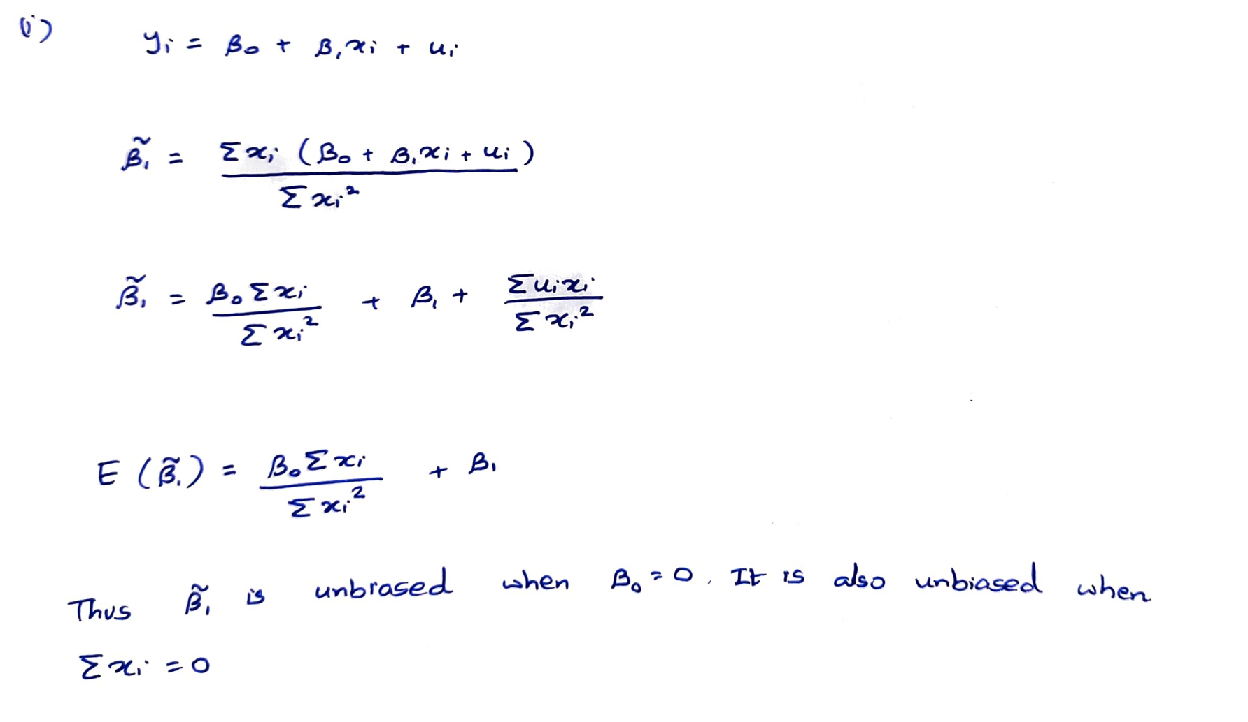



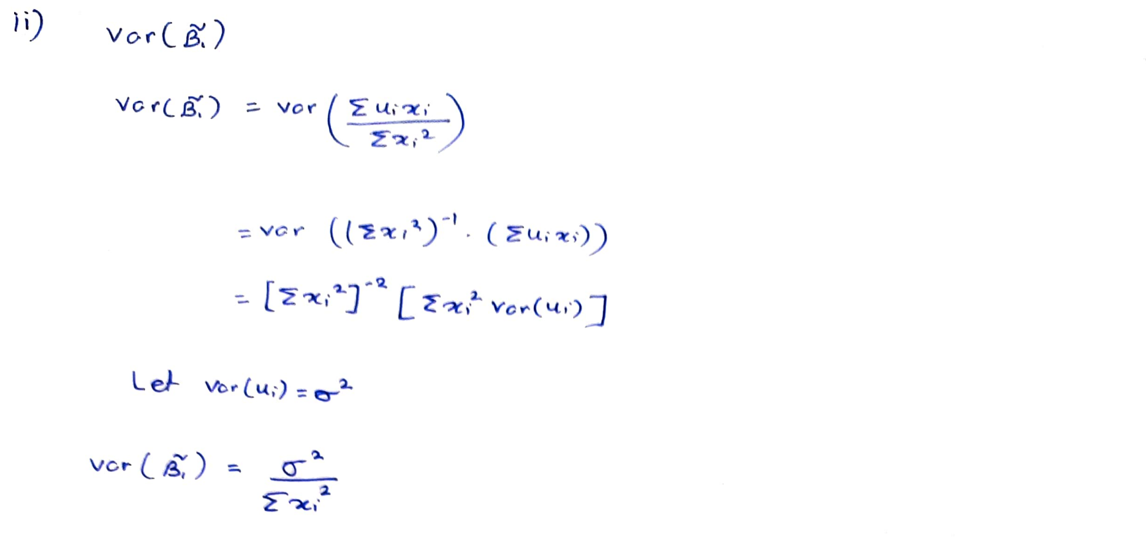



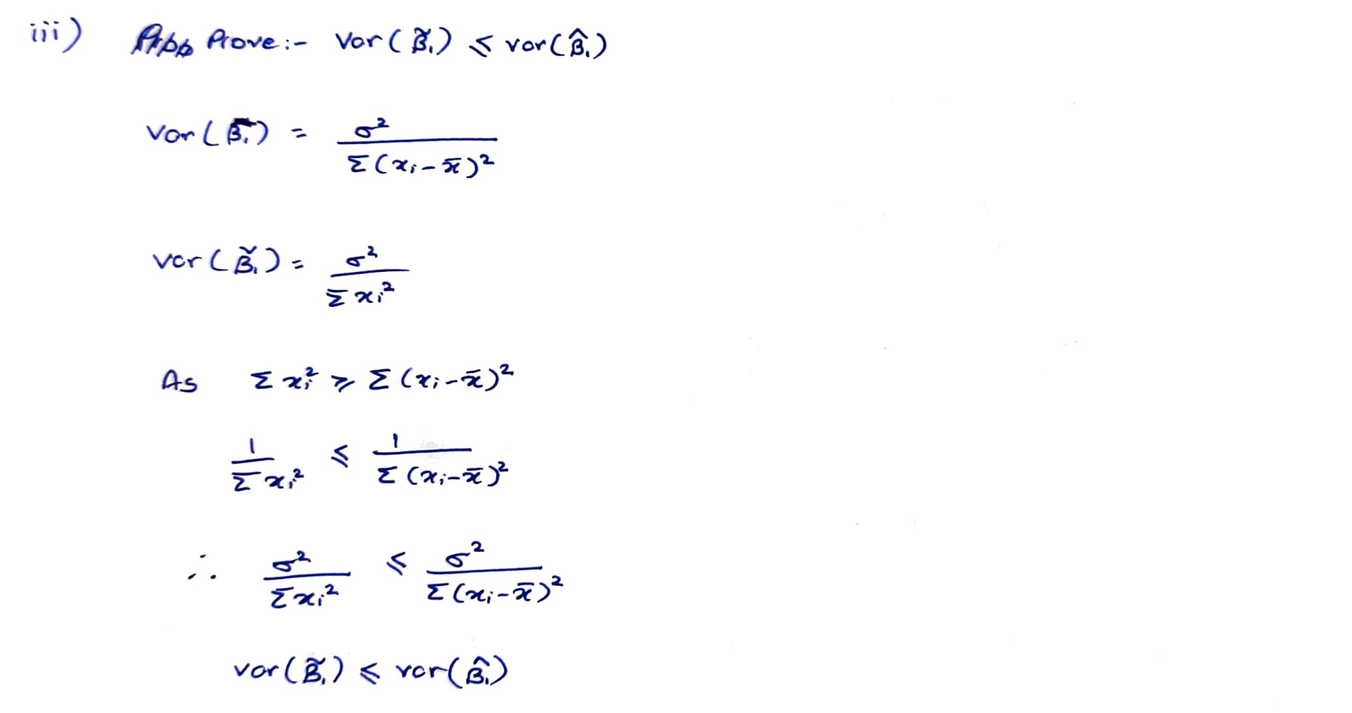



**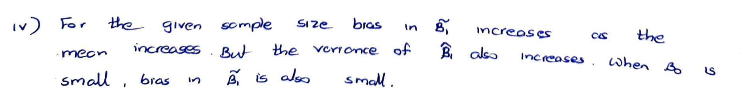**

**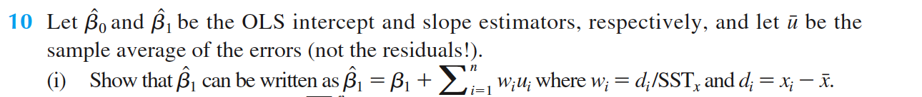**

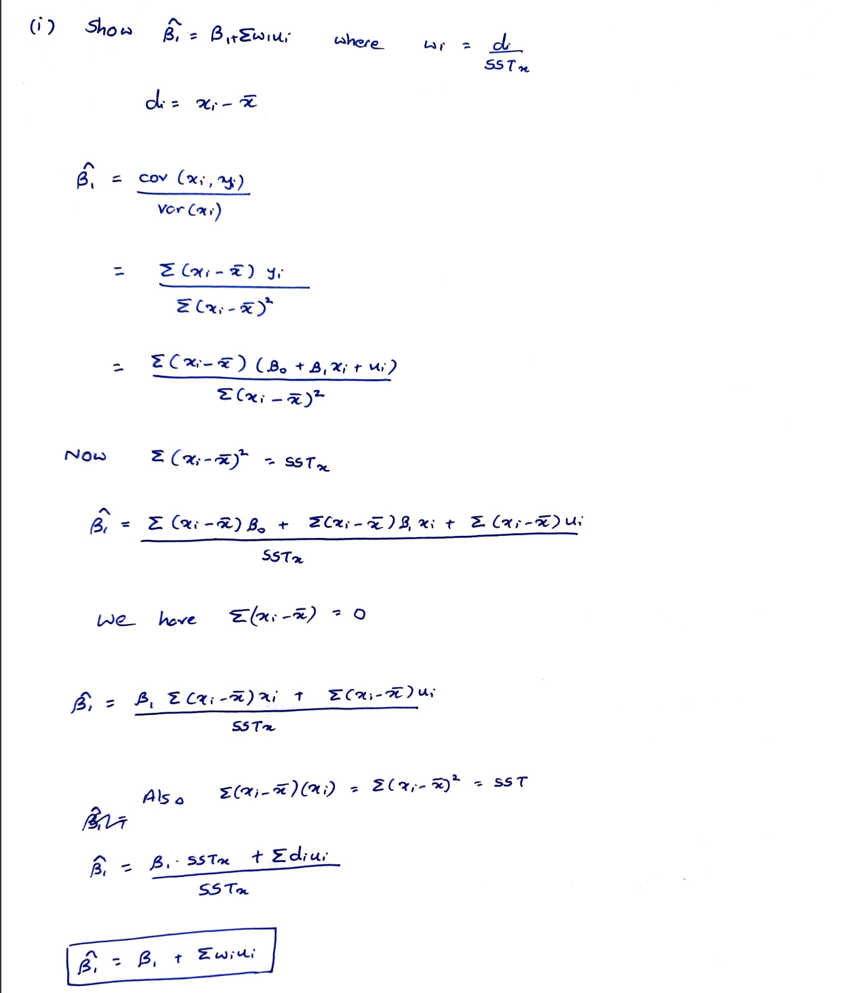

****

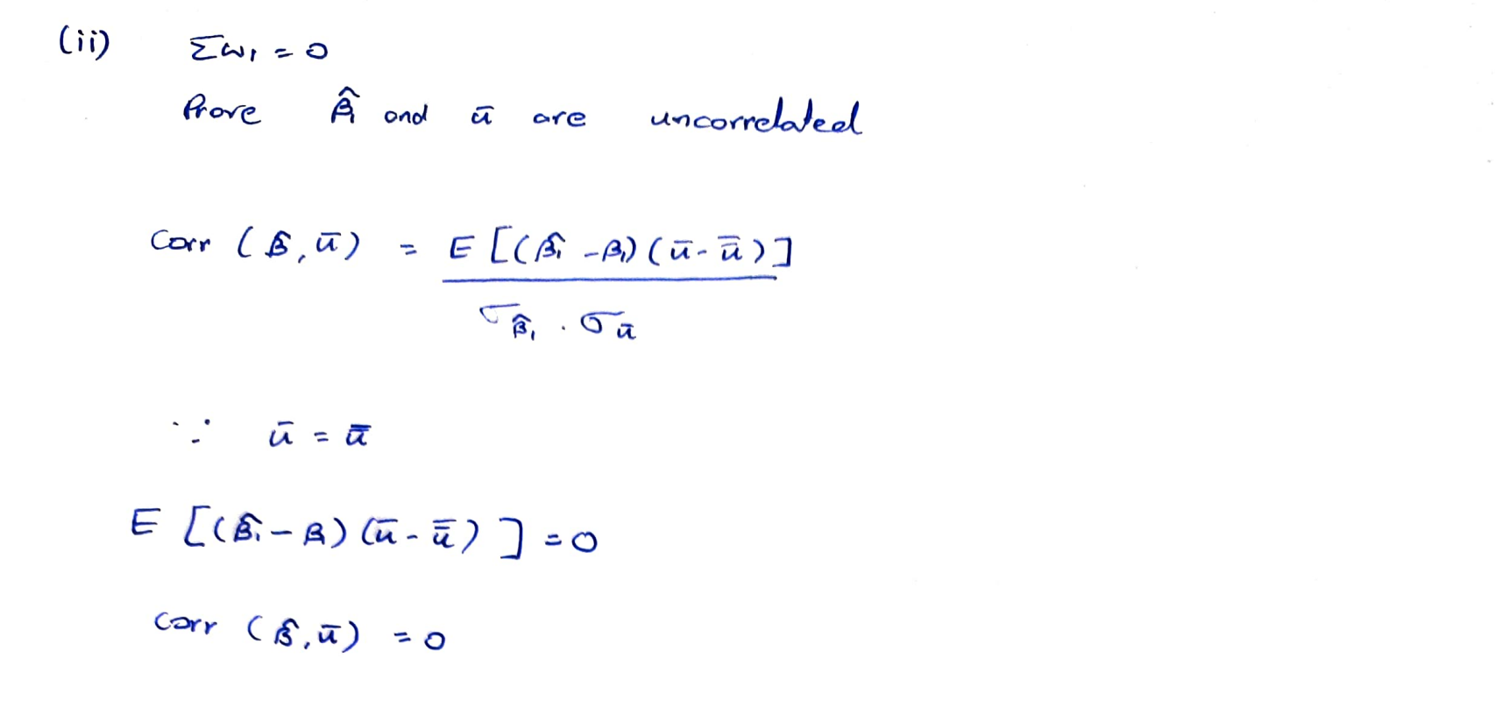



**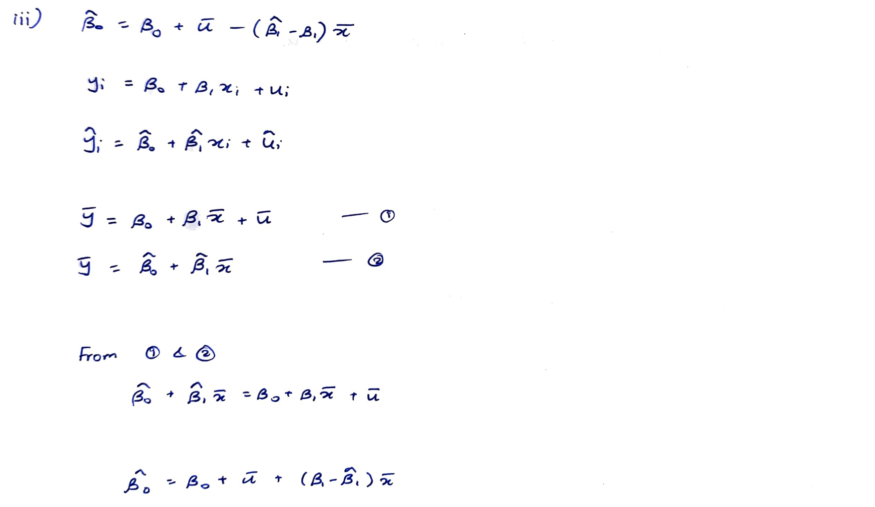**

****

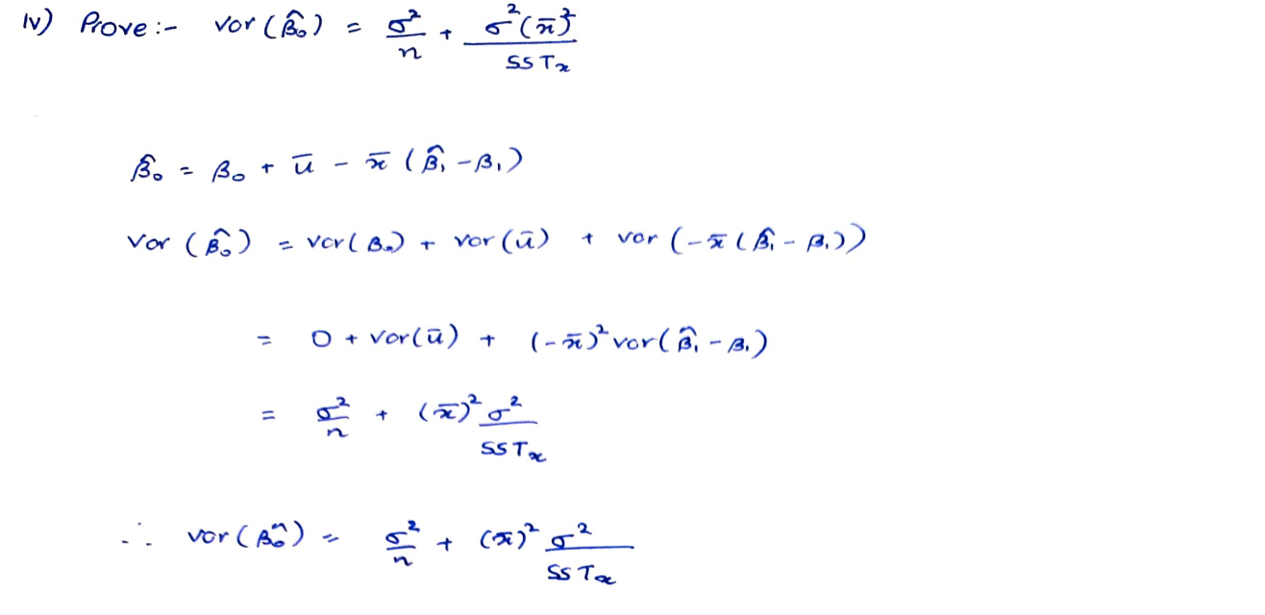

****

**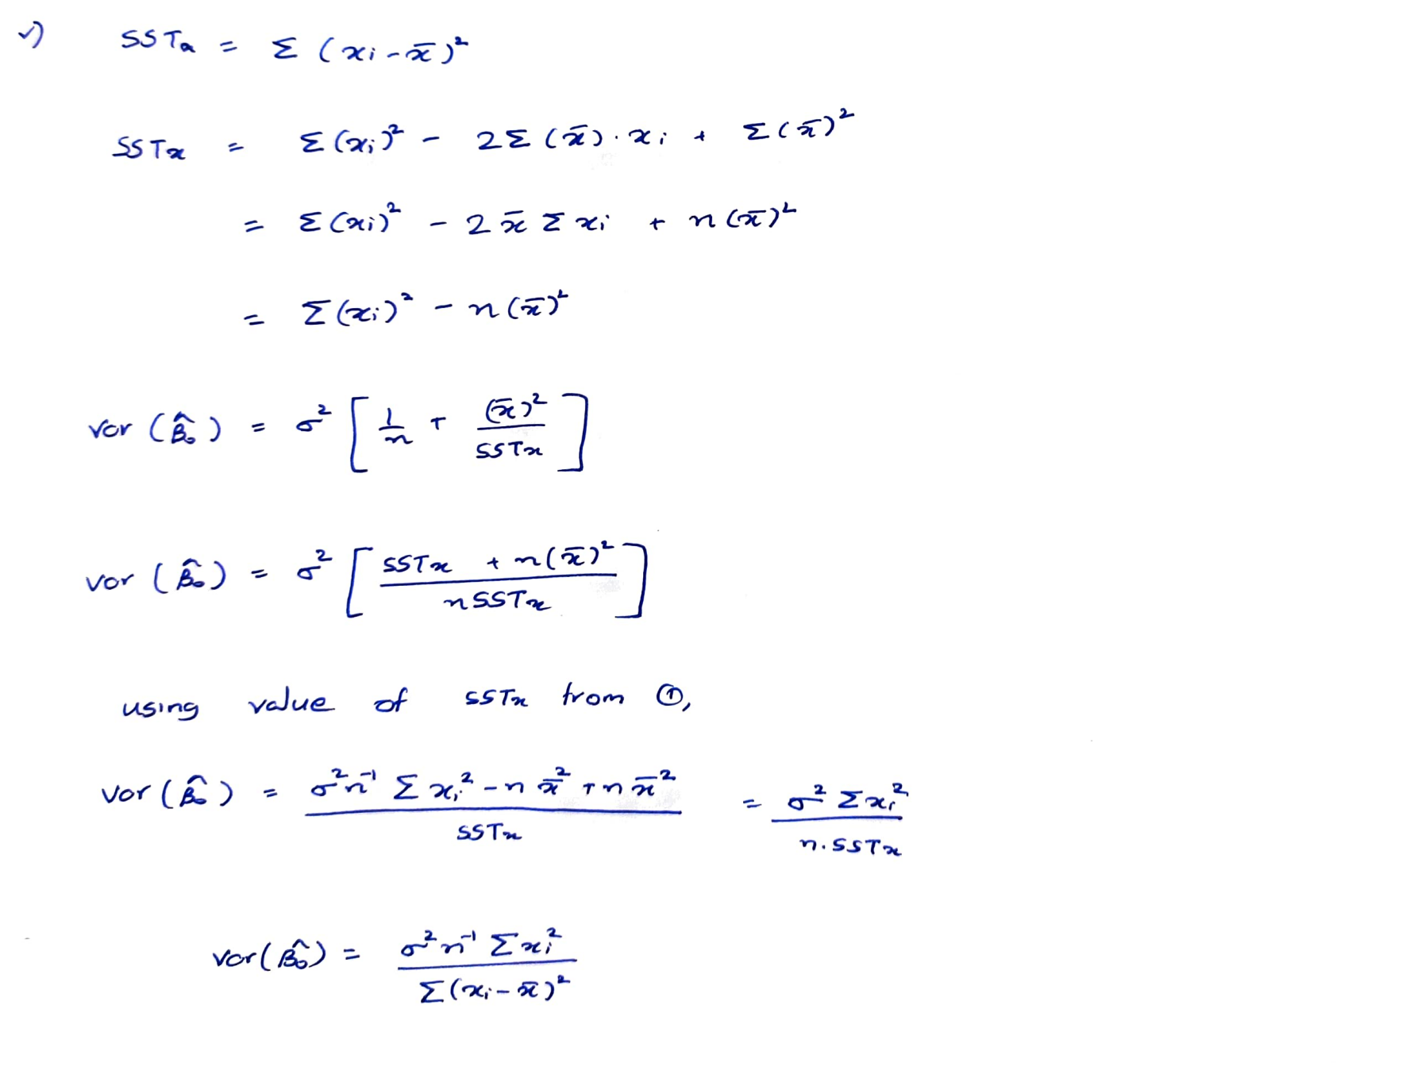**

**C1.** The data in 401K.RAW are a subset of data analyzed by Papke (1995) to study the relationship between participation in a 401(k) pension plan and the generosity of the plan. The variable prate is the percentage of eligible workers with an active account; this is

the variable we would like to explain. The measure of generosity is the plan match rate, mrate. This variable gives the average amount the firm contributes to each worker’s plan for each $1 contribution by the worker. For example, if mrate 5 0.50, then a $1

contribution by the worker is matched by a 50¢ contribution by the firm.

(i) Find the average participation rate and the average match rate in the sample of plans.

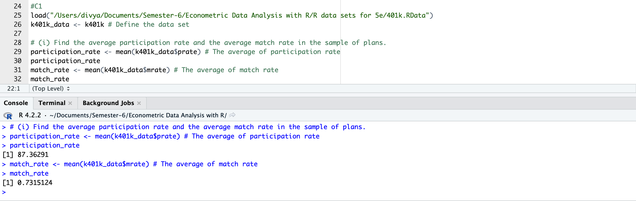

(ii) Now, estimate the simple regression equation

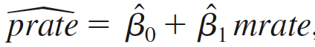

and report the results along with the sample size and R-squared.

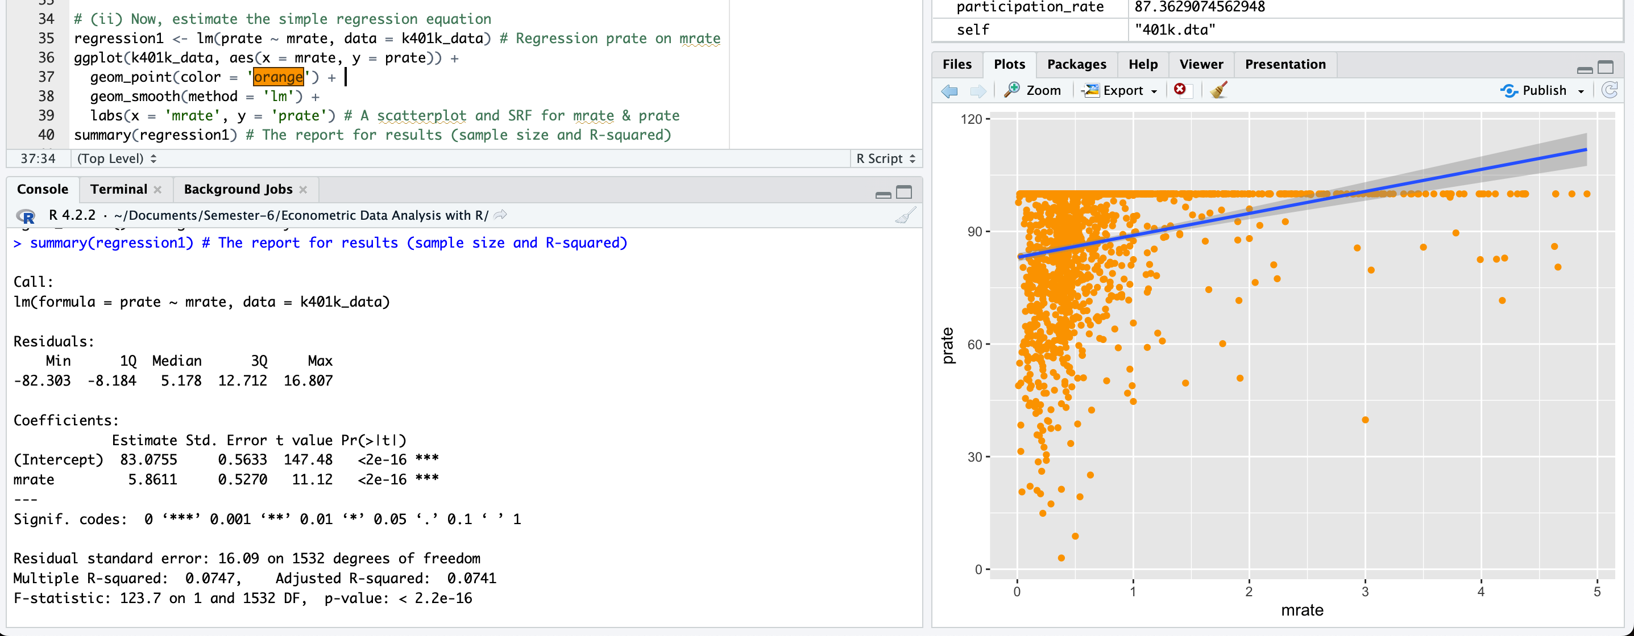

(iii) Interpret the intercept in your equation. Interpret the coefficient on mrate.

*The intercept implies that, even if mrate = 0, the predicted participation rate is 83.05 percent. The coefficient on mrate implies that a one-dollar increase in the match rate – a fairly large increase – is estimated to increase prate by 5.86 percentage points. This assumes, of course, that this change prate is possible (if, say, prate is already at 98, this interpretation makes no sense).*

(iv) Find the predicted prate when mrate 5 3.5. Is this a reasonable prediction? Explain what is happening here.

*If we plug mrate = 3.5 into the equation we get prate= 83.05 + 5.86(3.5) = 103.59. This is impossible, as we can have at most a 100 percent participation rate. This illustrates that, especially when dependent variables are bounded, a simple regression model can give strange predictions for extreme values of the independent variable. (In the sample of 1,534 firms, only 34 have mrate ≥ \_3.5.)*



(v) How much of the variation in prate is explained by mrate? Is this a lot in your opinion?

*mrate explains about 7.47% of the variation in prate. This is not much, and suggests that many other factors influence 401(k) plan participation rates. This is a relatively low value and indicates that there is not a strong relationship between the two variables in the sample. In this case, it is important to consider other factors that may affect participation rates, such as age, income, education, job tenure, etc.*

**C2**. The data set in CEOSAL2.RAW contains information on chief executive officers for U.S. corporations. The variable salary is annual compensation, in thousands of dollars, and ceoten is prior number of years as company CEO.

(i) Find the average salary and the average tenure in the sample.

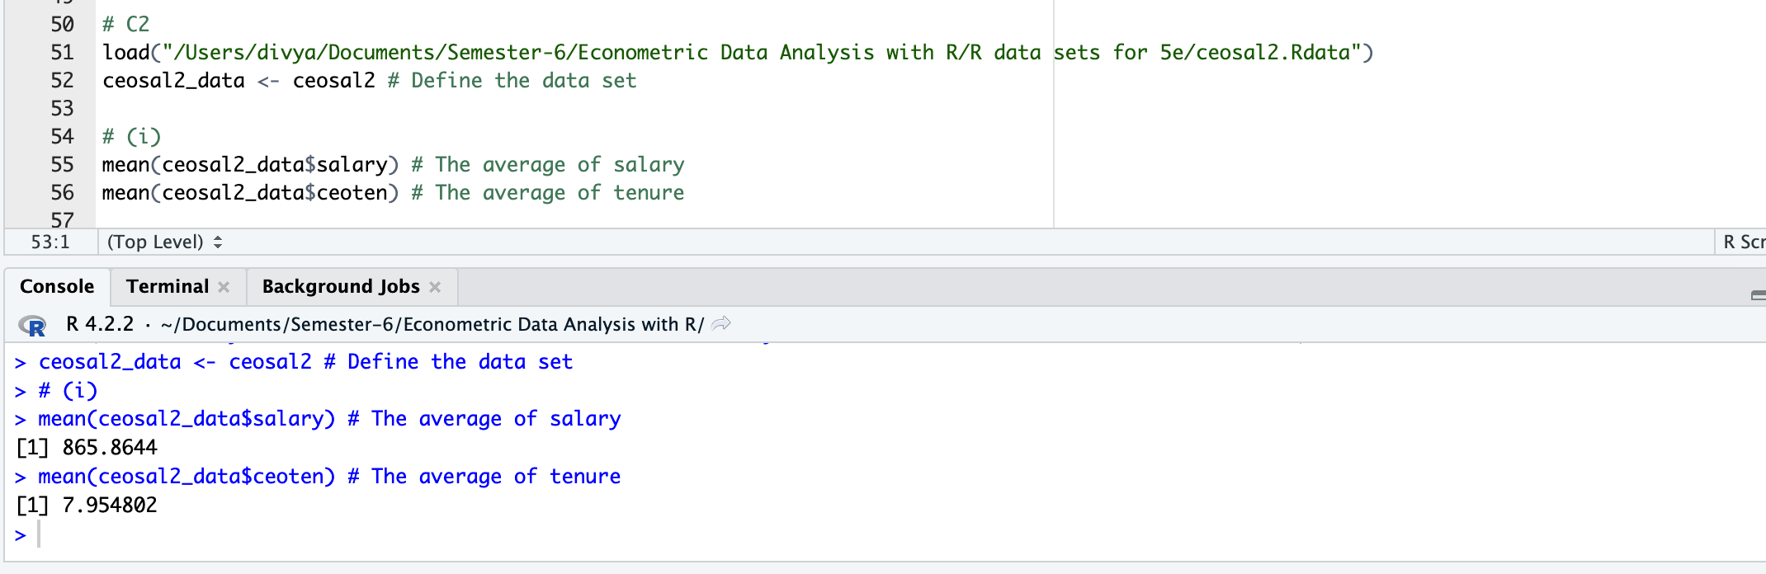

(ii) How many CEOs are in their first year as CEO (that is, ceoten 5 0)? What is the longest tenure as a CEO?

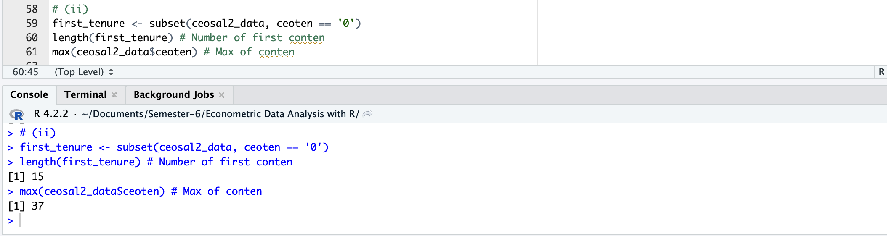

(iii) Estimate the simple regression model

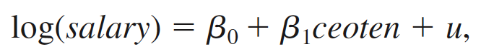

and report your results in the usual form. What is the (approximate) predicted percentage increase in salary given one more year as a CEO?

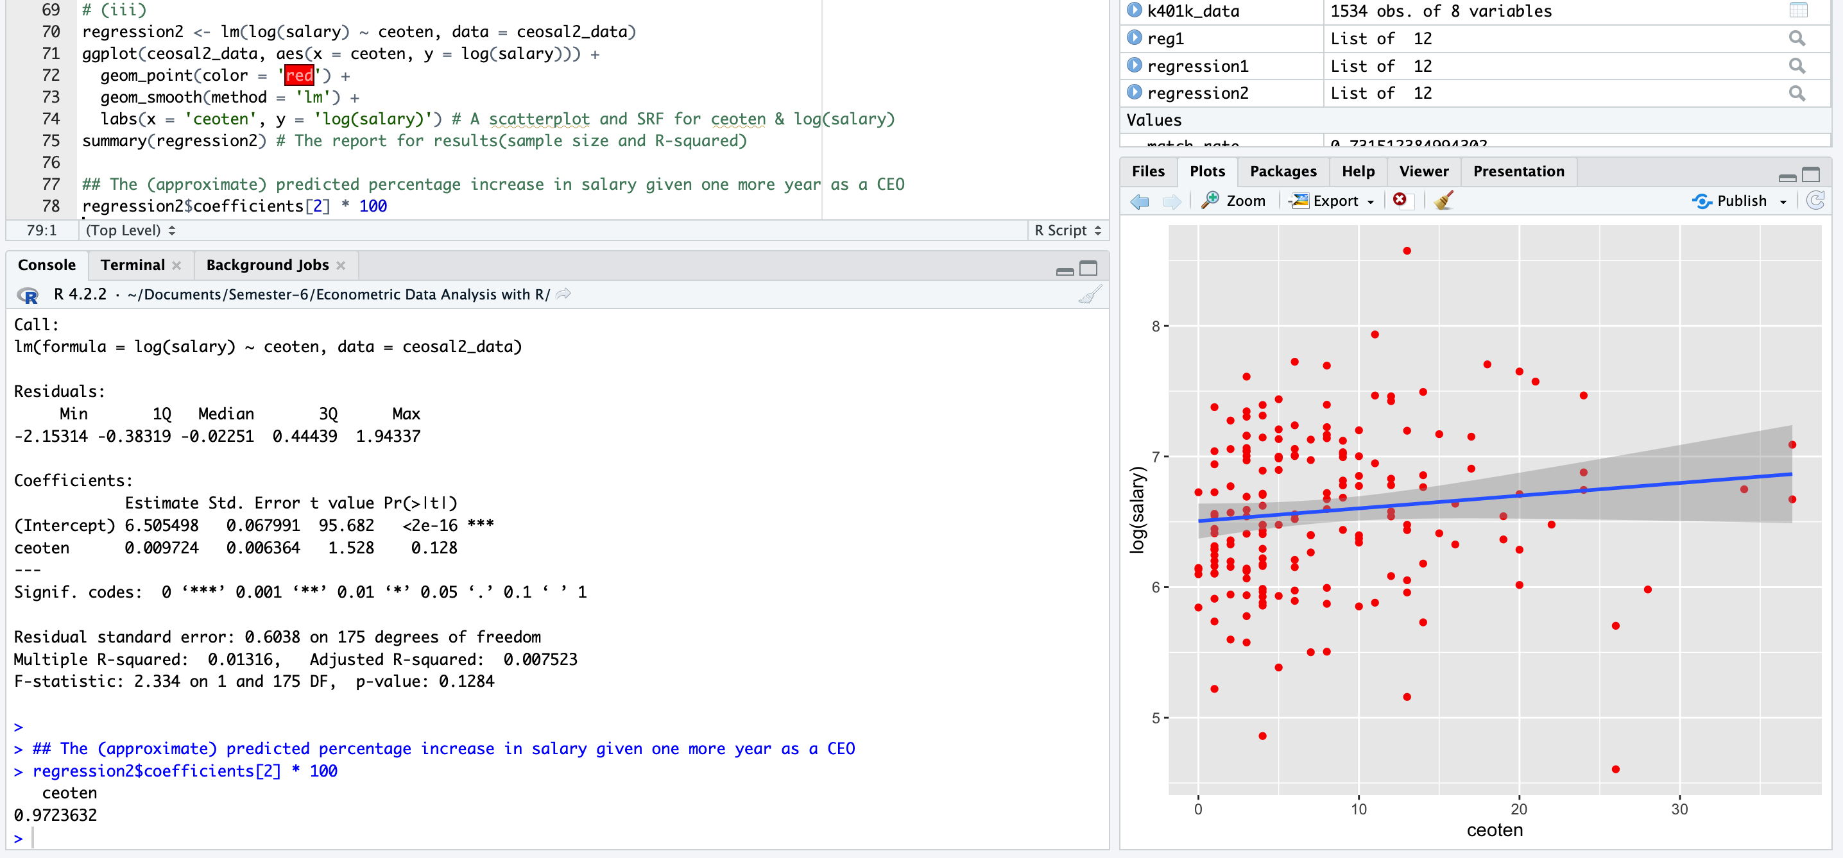

Predicted percentage increase in salary given one more year as a CEO:  **0.97236 %**

**C3**. Use the data in SLEEP75.RAW from Biddle and Hamermesh (1990) to study whether there is a tradeoff between the time spent sleeping per week and the time spent in paid work. We could use either variable as the dependent variable. For concreteness, estimate

the model

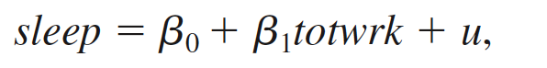

where sleep is minutes spent sleeping at night per week and totwrk is total minutes worked during the week.

(i) Report your results in equation form along with the number of observations and R2. What does the intercept in this equation mean?

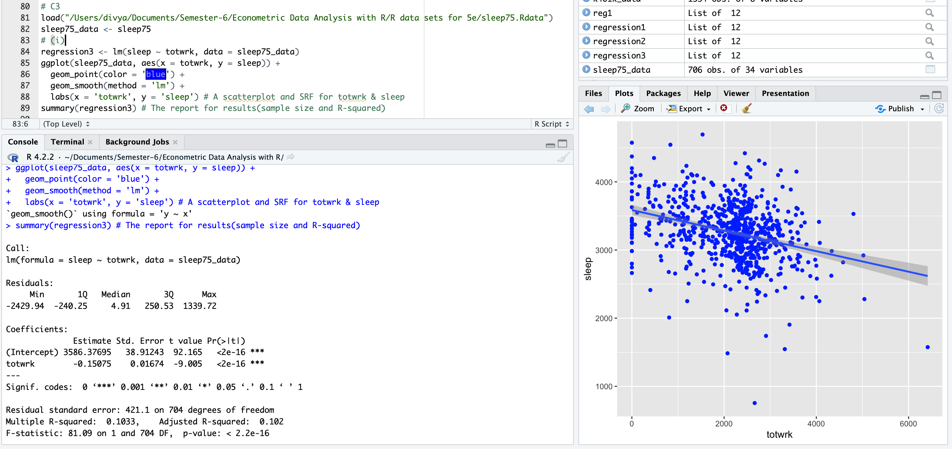

*The intercept implies that the estimated amount of sleep per week for someone who does not work is 3,586.4 minutes, or about 59.77 hours. This comes to about 8.5 hours per night.*

(ii) If totwrk increases by 2 hours, by how much is sleep estimated to fall? Do you find this to be a large effect?

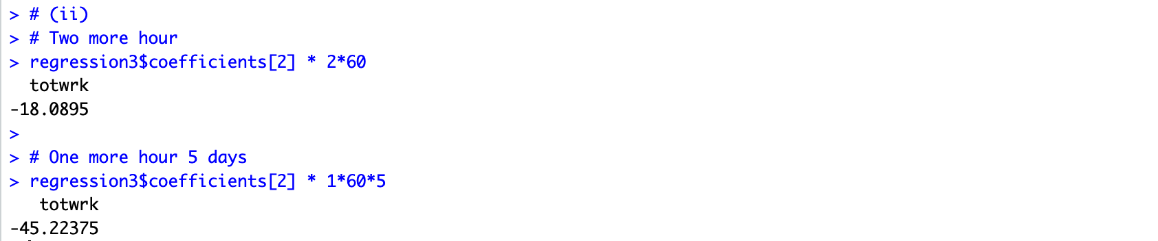

*If someone works two more hours per week then Δtotwrk = 120 (because totwrk is measured in minutes), and so Δ ssleep = –0.151(120) = –18.12 minutes.*

*If someone were to work one more hour on each of five working days, Δssleep = –45.22 minutes.*

C4 Use the data in WAGE2.RAW to estimate a simple regression explaining monthly salary (wage) in terms of IQ score (IQ).

(i) Find the average salary and average IQ in the sample. What is the sample standard deviation of IQ? (IQ scores are standardized so that the average in the population is 100 with a standard deviation equal to 15.)

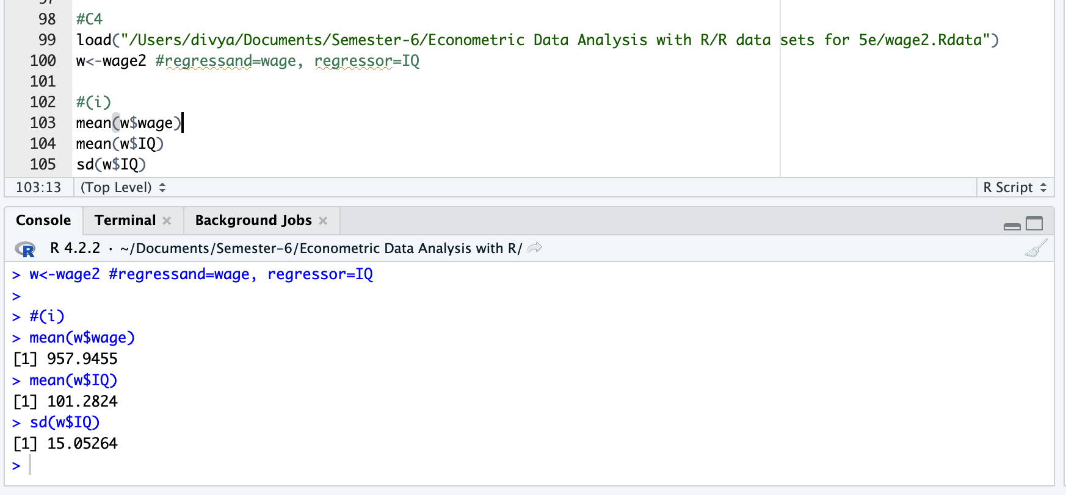

(ii) Estimate a simple regression model where a one-point increase in IQ changes wage by a constant dollar amount. Use this model to find the predicted increase in wage for an increase in IQ of 15 points. Does IQ explain most of the variation in wage?

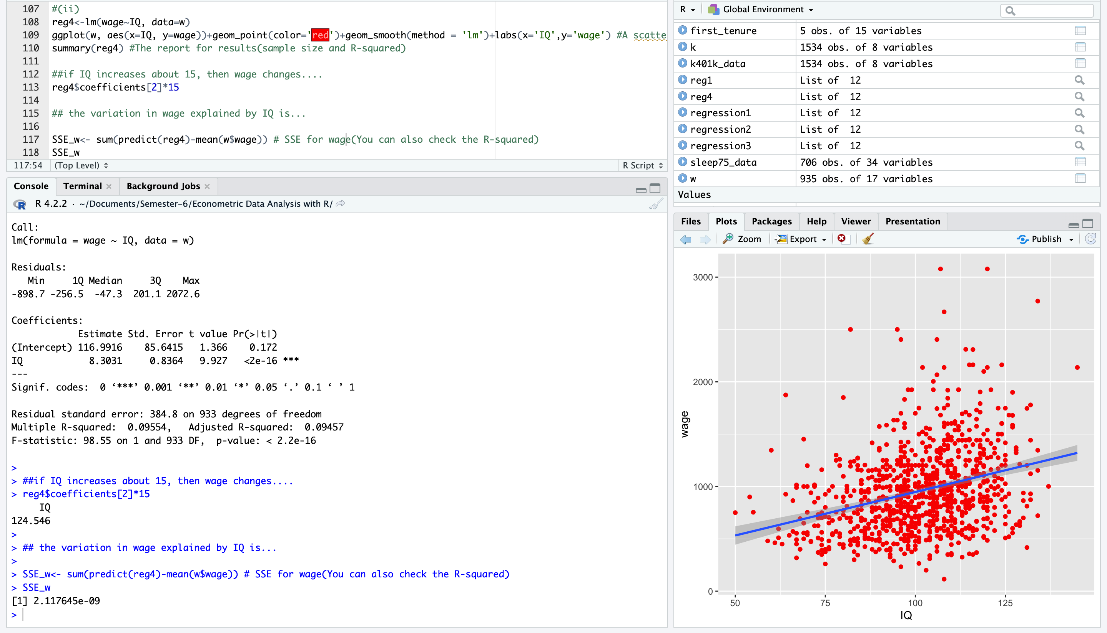

**Increase in wage = 124.546**

The R-squared value of the regression is 0.09554, which means that IQ explains only **9.5%** of the variation in wage. This suggests that there are other factors beyond IQ that affect salary.

(iii) Now, estimate a model where each one-point increase in IQ has the same percentage effect on wage. If IQ increases by 15 points, what is the approximate percentage increase in predicted wage?

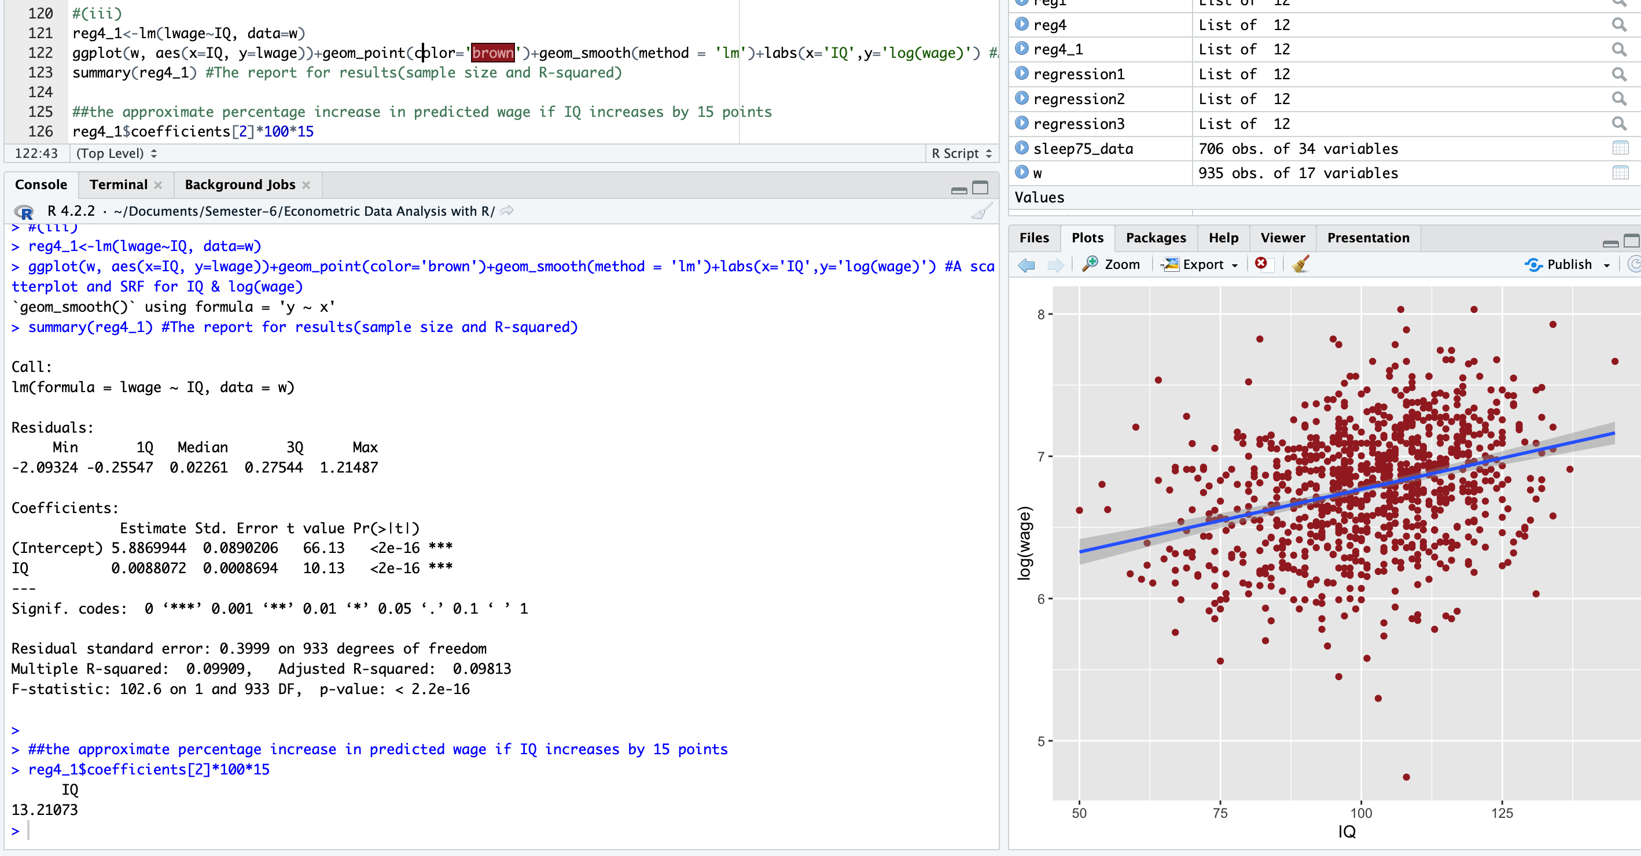

**Percentage Increase in Wage = 13.21**

**C5**. For the population of firms in the chemical industry, let rd denote annual expenditures on research and development, and let sales denote annual sales (both are in millions of dollars).

(i) Write down a model (not an estimated equation) that implies a constant elasticity between rd and sales. Which parameter is the elasticity?

*The constant elasticity model is a log-log model:*

*log(rd) = β0 + β1 log(sales) + u,*

*where β1 is the elasticity of rd with respect to sales.*

(ii) Now, estimate the model using the data in RDCHEM.RAW. Write out the estimated equation in the usual form. What is the estimated elasticity of rd with respect to sales? Explain in words what this elasticity means.

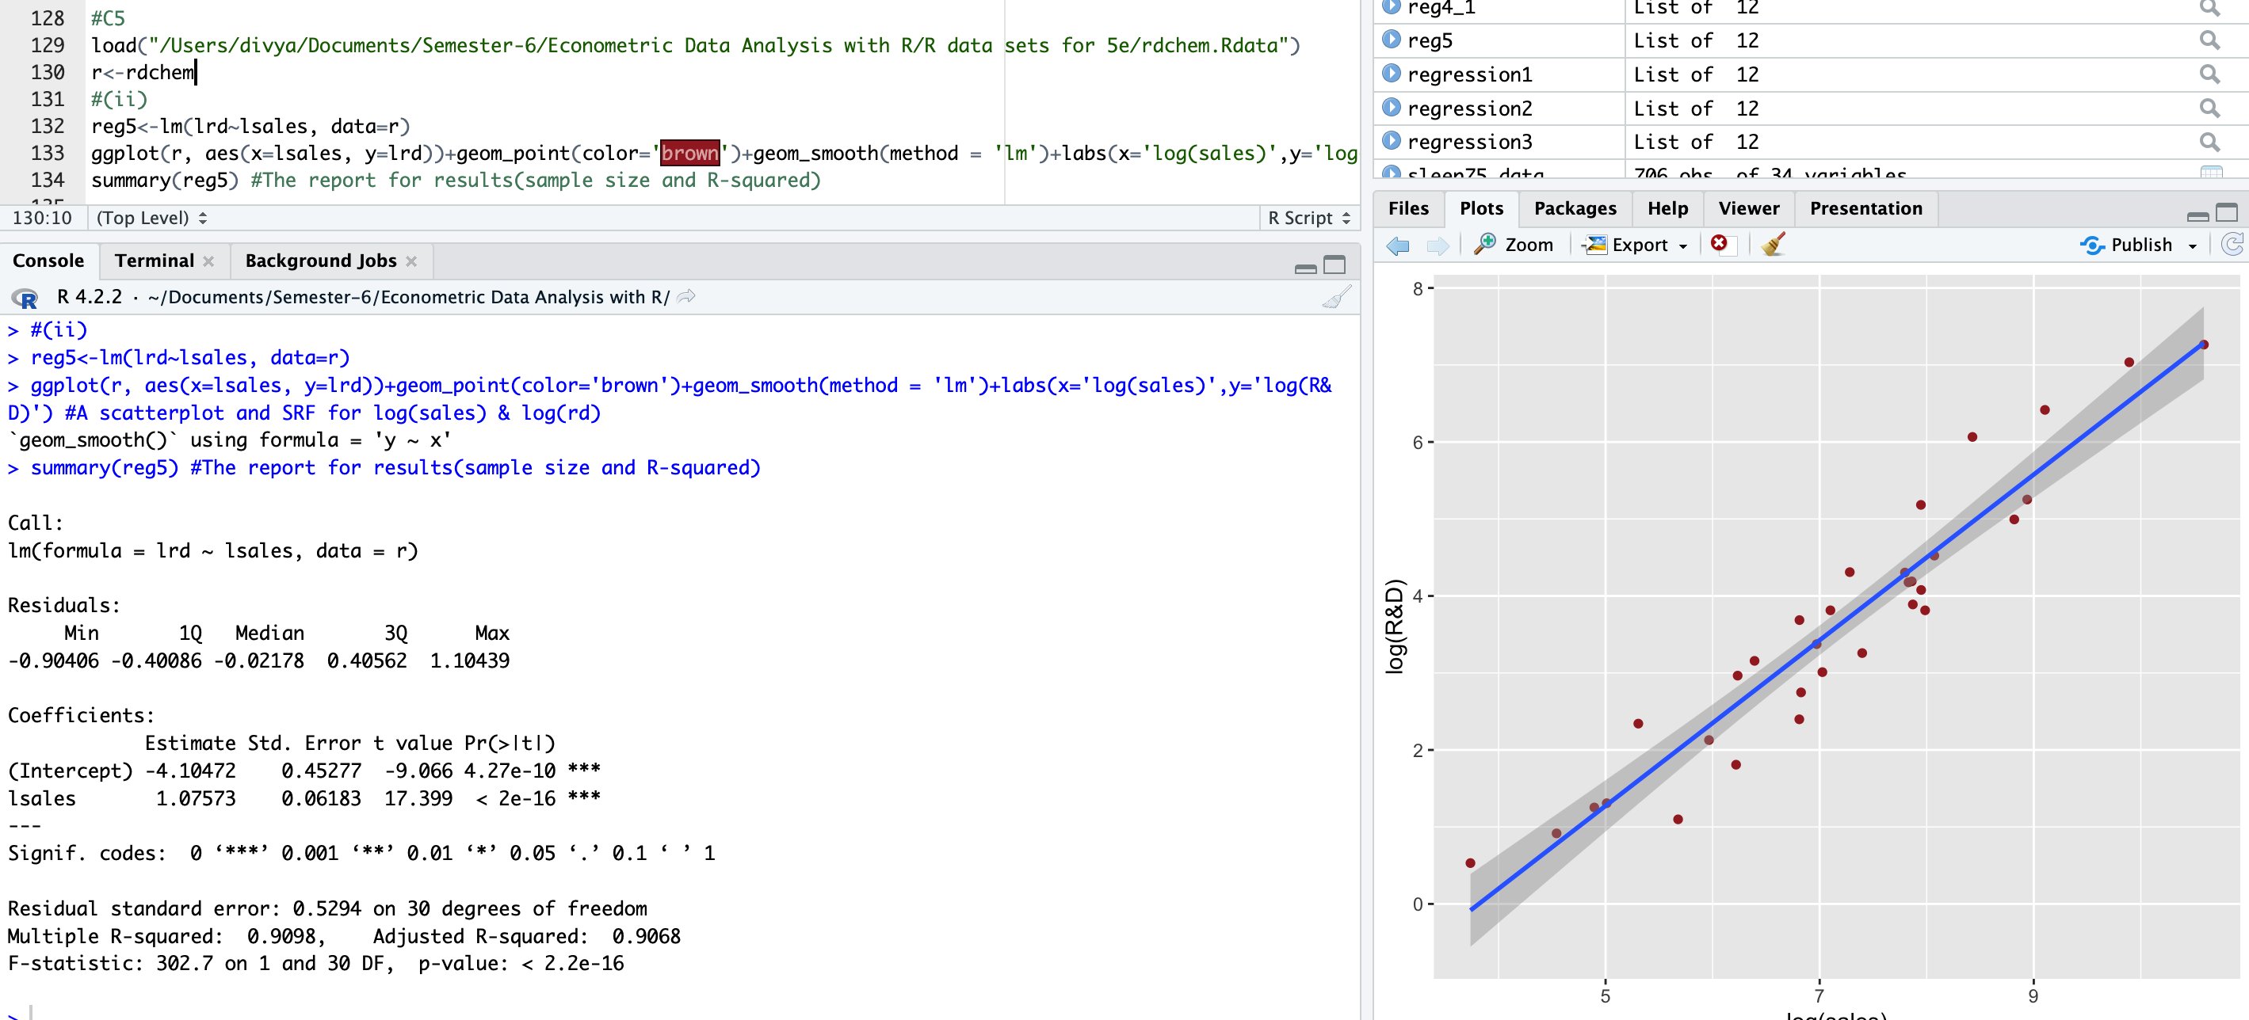

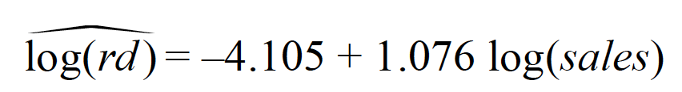

*R2 = 0.9098*

*The estimated elasticity of rd with respect to sales is 1.07573, which is just above one. A one increase in sales is estimated to increase rd by about 1.07573%.*

C8. To complete this exercise you need a software package that allows you to generate data from the uniform and normal distributions.

(i) Start by generating 500 observations xi – the explanatory variable – from the uniform distribution with range [0,10]. (Most statistical packages have a command for the Uniform[0,1] distribution; just multiply those observations by 10.) What are the sample mean and sample standard deviation of the xi?

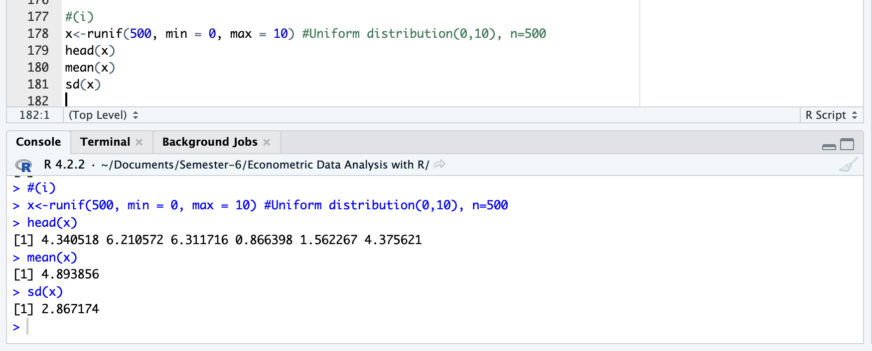

(ii) Randomly generate 500 errors, ui, from the Normal[0,36] distribution. (If you generate a Normal[0,1], as is commonly available, simply multiply the outcomes by six.) Is the sample average of the ui exactly zero? Why or why not? What is the sample standard deviation of the ui?

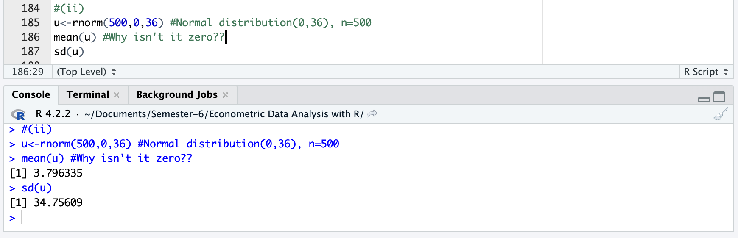

(iii) Now generate the yi as

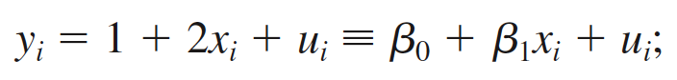

that is, the population intercept is one and the population slope is two. Use the data to run the regression of yi on xi. What are your estimates of the intercept and slope? Are they equal to the population values in the above equation? Explain

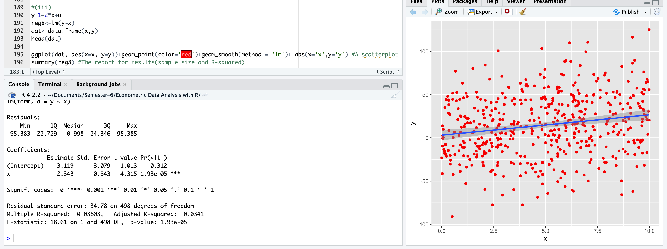

(iv) Obtain the OLS residuals, uˆi, and verify that equation (2.60) hold (subject to rounding error).

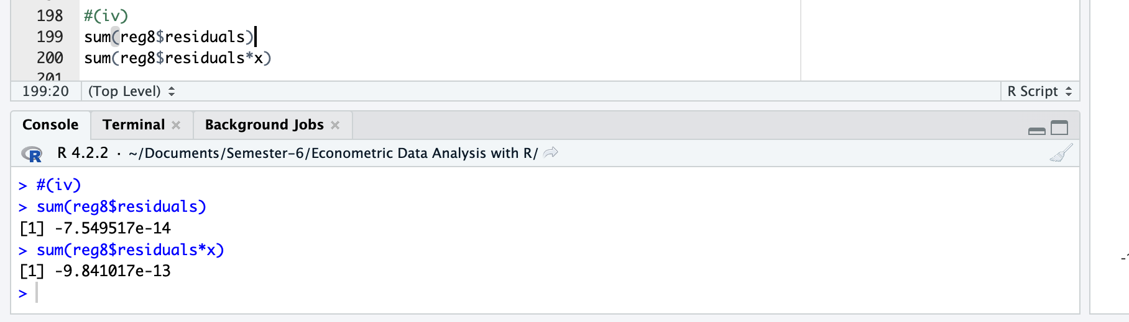

(v) Compute the same quantities in equation (2.60) but use the errors ui in place of the residuals. Now what do you conclude?

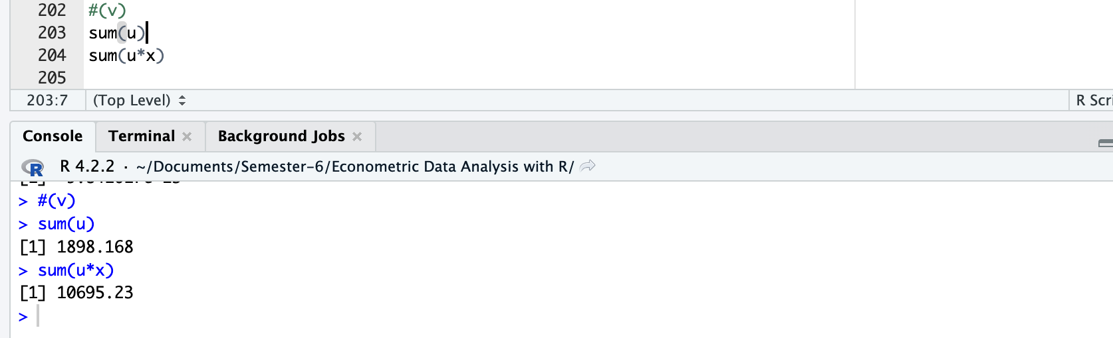

(vi) Repeat parts (i), (ii), and (iii) with a new sample of data, starting with generating the xi. Now what do you obtain for bˆ0 and bˆ1? Why are these different from what you obtained in part (iii)?

